
- Compatible with syringes of any brands of sizes, 5ml, 10ml, 20ml/30ml and 50/60ml.
- Automatic syringe detection & easy calibration any syringe.
- Four working modes: Rate control, Time control, Body weight control and sequential mode.
- Color LCD Display
- Purge / Bolus Function.
- Drug Library
- Event History Recall
- Anti Bolus Function - Auto pressure release after occlusion alarm
- Three levels of the occlusion limited pressure: high, medium and low.
- Three level of alarm sound high, medium and low.
- Syringe pump goes into KVO mode automatically as infusion is completed.
- Built in rechargeable Li Battery with 8 hours backup
- 12 volt DC input socket for battery charging during ambulance
RS-232 port for software upgradation
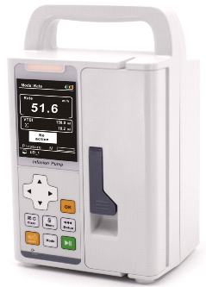
- Delivery range: 0.1ml/h~1200ml/h.
- · High accuracy +/ - 2% after correct calibrated.
- · Five work modes: Rate Mode, Time Mode, Dose Mode, Sequential Mode and
- Drug library Mode.
- · Manual or Automatic Bolus and Purge/KVO function can be adjustable .
- · Vertical & Horizontal mounting clamp.
- · Anti-bolus system to reduce significantly after occlusion sudden release.
- · DPS dynamic pressure display.
- · 2000 events stored can be checked and downloaded.
- · Large color TFT display, the brightness can be adjusted to adapt to the clinical
- use of the environment.

